NP – FLASH STROBO
Navigation / Position / Strobe LED light
SPECIFICATION:
Input Voltage Range: | 10–15 V
Input Current (for 13 V):
- 3 in 1 Combined light: | average 0.36 A, peak 1.5 A
- Strobe: | average 0.60 A, peak 1.2 A
Weight: | apx. 80 g
Dimensions (mm) length x width x hight:
- 3 in 1 Combined light: | 107 mm x 44 mm x 35 mm
- Strobe: | 107 mm x 44 mm x 35 mm
Waterproof body: | yes
Reverse Polarity and Overheating Protection: | yes
Rear White Light (navigation): | permanently ON
Front Green / Red Light (position): | permanently ON
Repetition Rate of Strobe Light: | 3 short flashes every 1 second
Strobe Beam Angle: | 180°

DESCRIPTION:  Package includes mounting screws.  The standalone anti-collision strobe only has a flash function (white or red light).  For installation you will need (not included):  - a switch  - a wire 2 x 0,5mm² / each light  - a fuse 2A / each light  All components are integrated into the body of the light.  LEDs are oversized to provide longer lifetime period.  Clear cover, electronic components and LEDs are replaceable. Lights can be serviced.  You must specify in your order If you need us to synchronize two standalone strobe lights. | 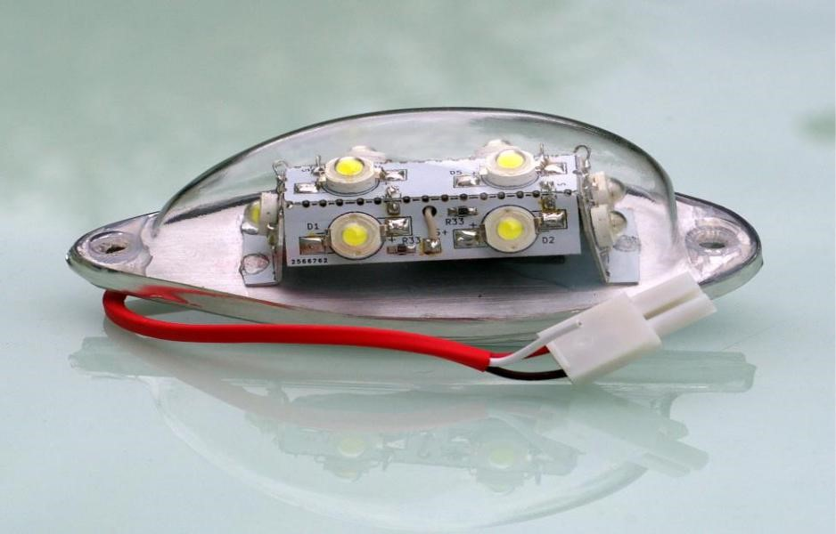
WARRANTY:
We provide 3-year warranty on unmodified lights.
Free of charge repairs DO NOT cover shipping costs from and back to the customer.

!!! WARNING !!!
Positive (+) power supply line wire is RED with a square socket.
Strobe Synchronization line wire is WHITE, control unit is placed inside of the red (position) light.
Mounting screws must not be tighten with a strong force – to add additional strength secure with a Locktite glue.
Lights has been tested on ultra-light airplanes up to the speed of 165 km/h.

NOT APPROVED FOR INSTALLATION ON CERTIFIED AIRCRAFT
THIS IS NOT A TSO/ETSO CERTIFIED LIGHT
Dealer contact information:

